No Longer Standards in 3rd Grade | New Standards in 3rd Grade
Money  Odd and Even  Change over time  Lines, rays, etc.  Parallels  Triangles  Circles  Polygons  Transformations  Range  Probability | Equivalent Fractions  Representation of Fractions  Equations  Properties  Pictograph, line plot, bar graph  Quadrilaterals
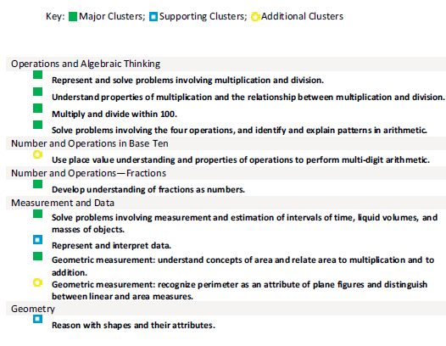

No Longer Standards in 4th Grade | New Standards in 4th Grade
Probability  Data Analysis  Congruence  3D Figures  Transformation  Equations and Expressions  Coordinate Plane (5)  Change over Time  Add and Subtract Decimals  Patterns | Line Plots  Parallel Lines  $ (decimal notation)  Add and Subtract Fractions  Multiply Fractions  Multi-step equations  Properties  # Theory  Measuring angles  Prime and Composite Numbers  Circles
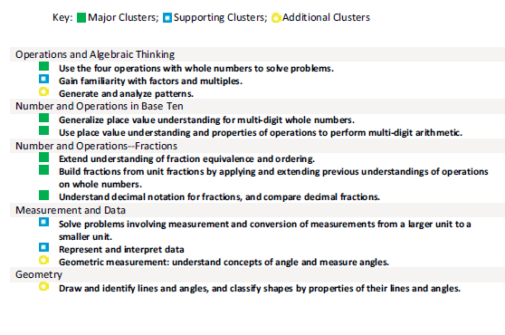

No Longer Standards in 5th Grade | New Standards in 5th Grade
Probability and Statistics  Divisibility  Prime and Composite  Angles  Mass  Time and Temp  Rate of Change  Congruence  Triangles and Quadrilaterals  3D Shapes  Symmetry  Transformations | Scientific Notation  Order of Operations  # theory  Equivalent fractions  Fraction operations(add, subtract, mult, and div)  Coordinate plane  Polygons  Line plots

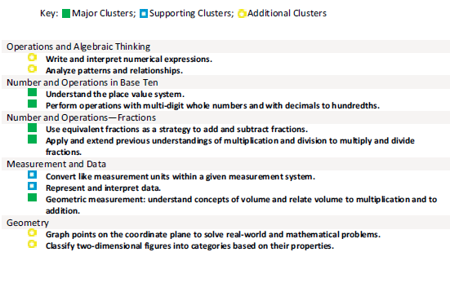

No Longer Standards in 6th Grade | New Standards in 6th Grade
Patterns  Prime, Composite, and Squares  Conversions  Navigation  Angles  Circles – Pi  Pie charts  Stem and Leaf  Probability  Spheres, cones, and cylinders  Similarity and congruence | Rates  Multi-operation integers and fractions  Equivalent fractions  Computing with percentages  Points, lines, rays, vectors  Box plots and line plots  Tree diagrams  Variability, deviation, range  Polynomials  Absolute value
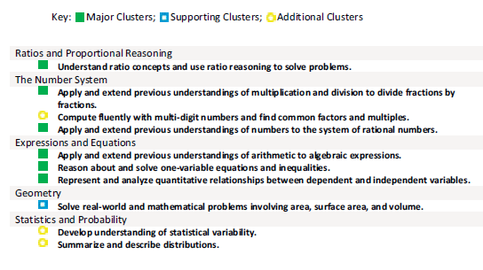

No Longer Standards in 7th Grade | New Standards in 7th Grade
Computing exponents and radicals  Percentages  Metric system  Patterns  Square roots and radicals  Congruence  Parallels  Circles  Transformations  Pie and circle chart  Box plots | Equivalence of fractions, decimals, and percentages  Computing with percentages  Properties  Circle  Rate and Speed  Evaluations of formulas  Coordinate planes  Non linear and linear relationships  Operations of polynomials  Rational expressions  Geometric modules  Data in table
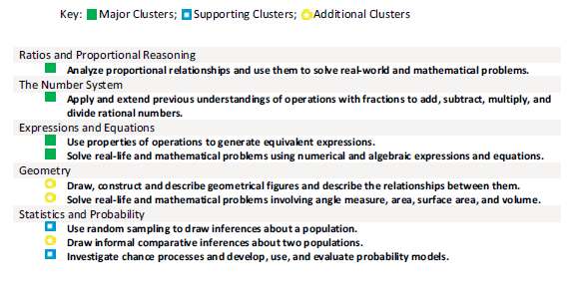

No Longer Standards in 8th Grade | New Standards in 8th Grade
Integer operations  Multiplying and dividing fractions  Ration and proportions | Equivalency of decimals, fractions, and percentages  Multiplying and dividing decimals  Computing with exponents and radicals
